# CS 255 System Design Document Template

## UML Diagrams

### UML Use Case Diagram

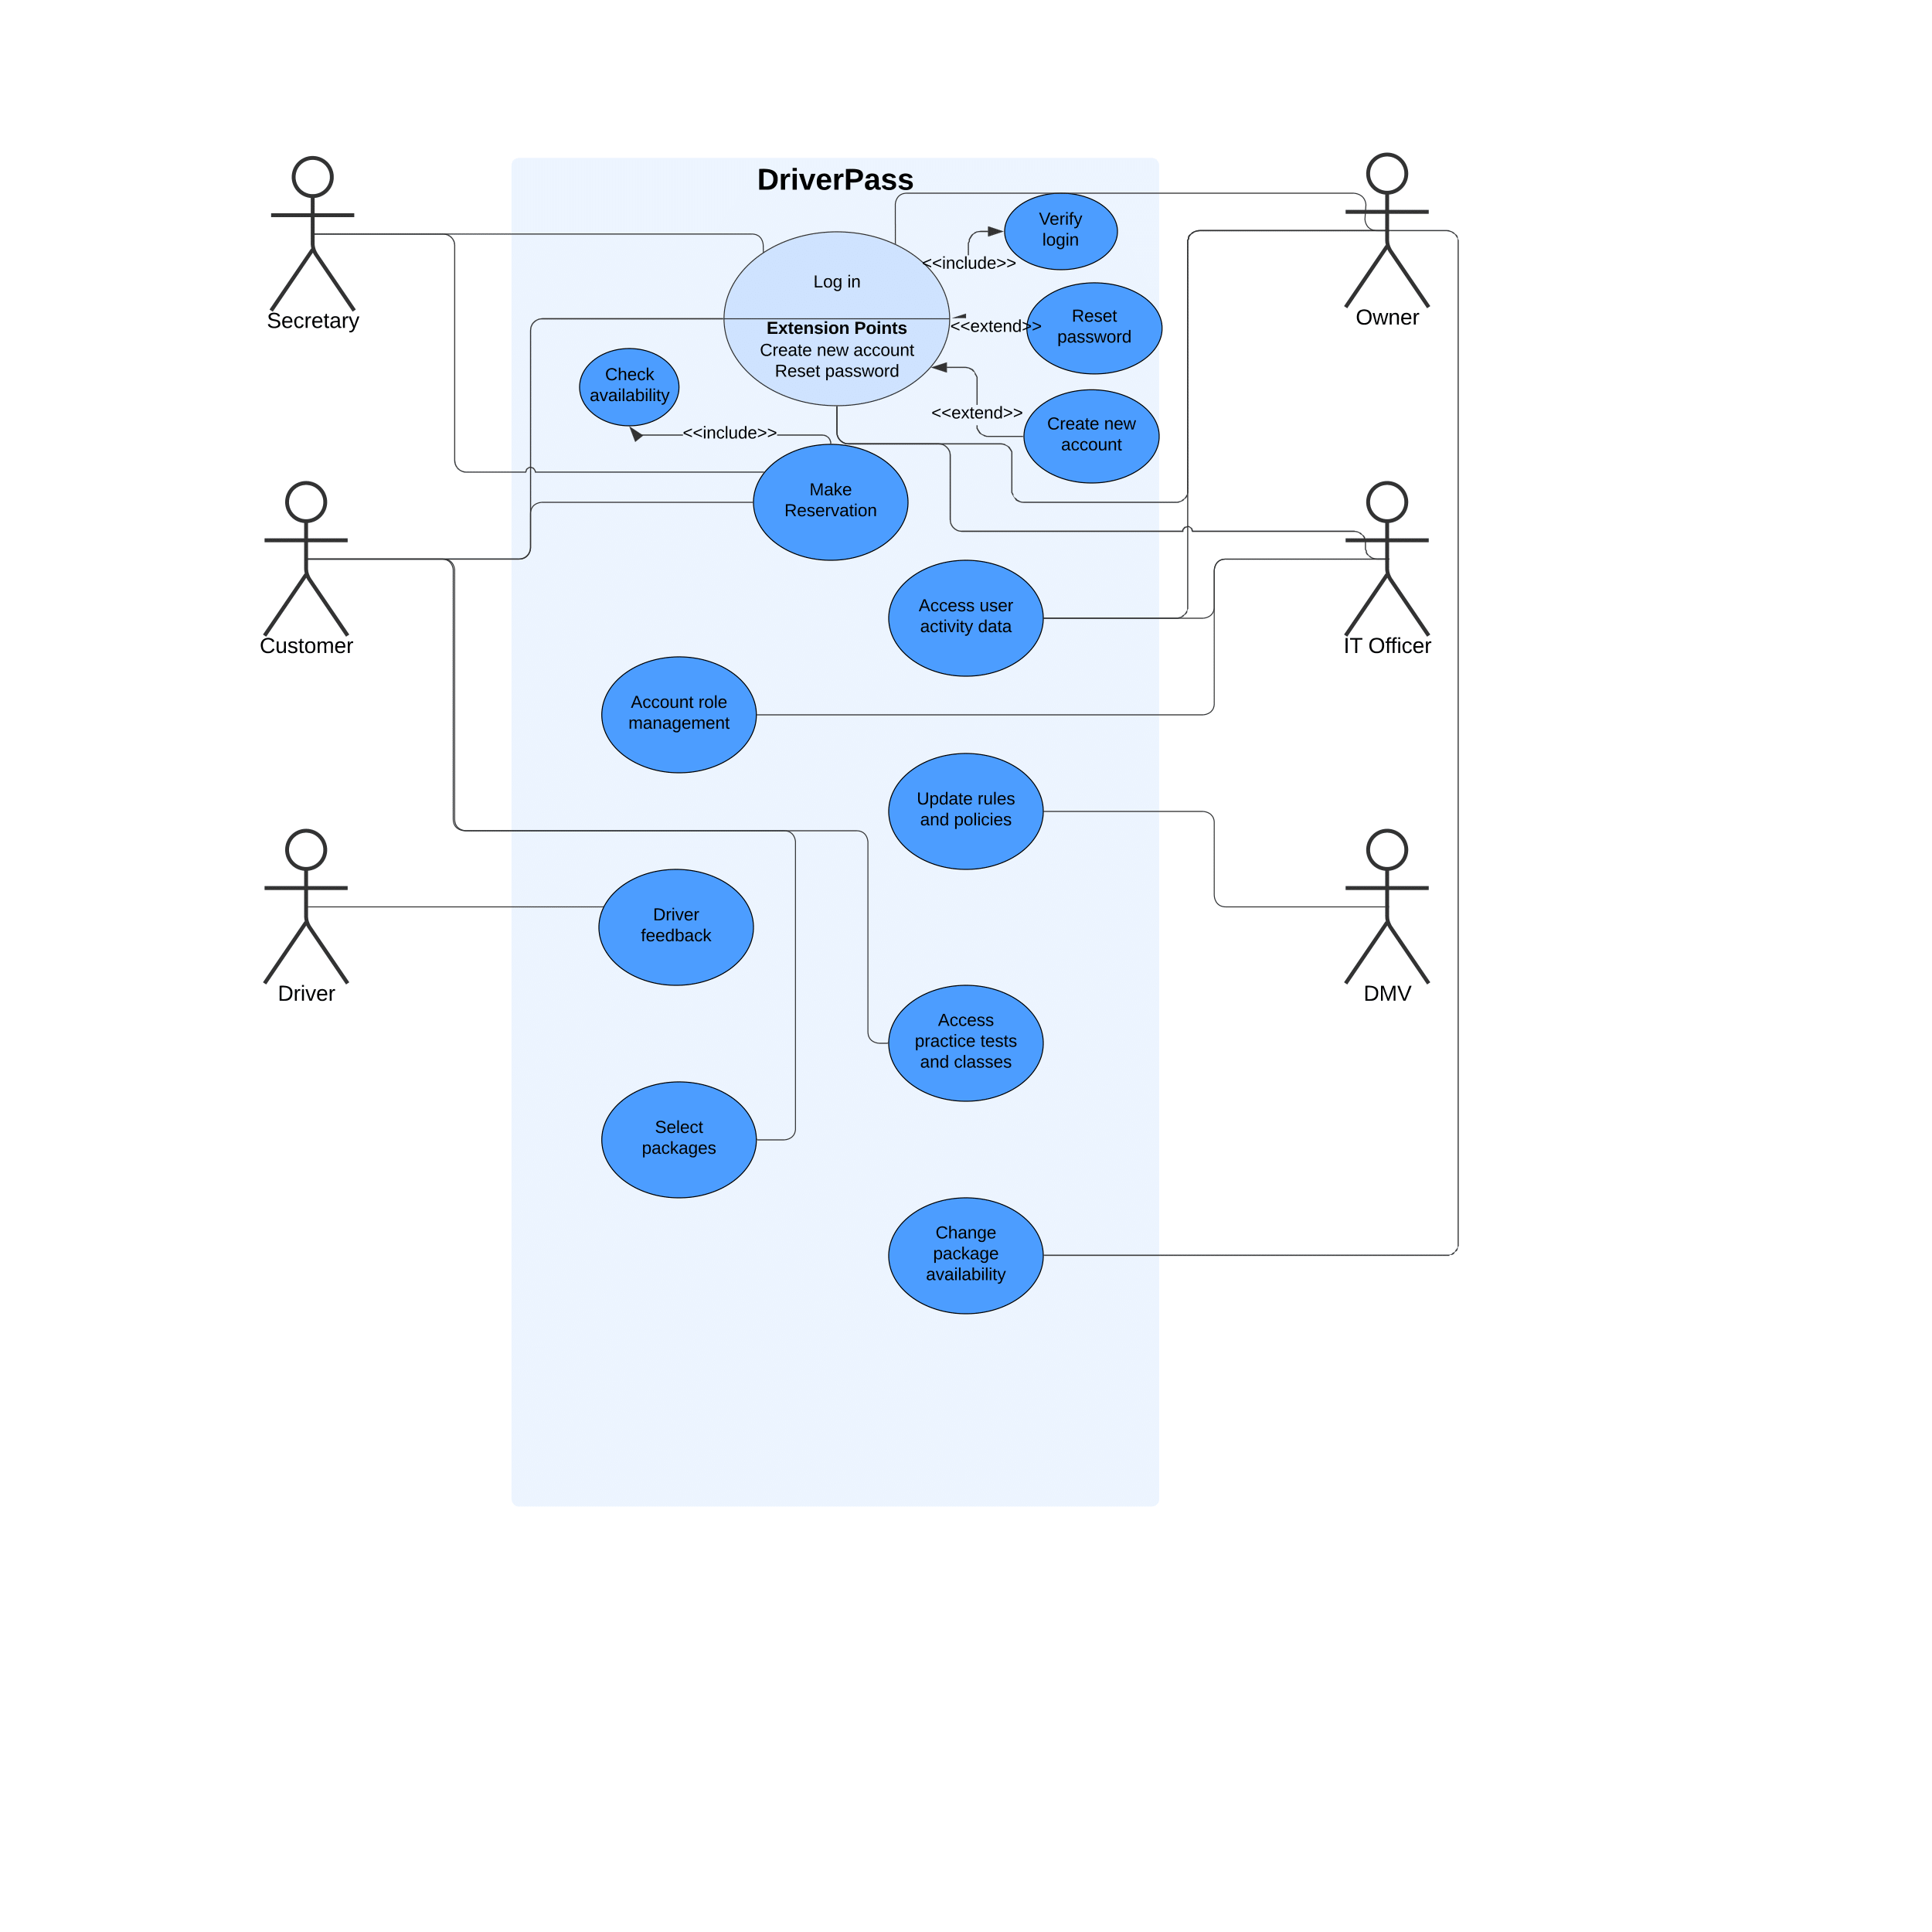

### UML Activity Diagrams

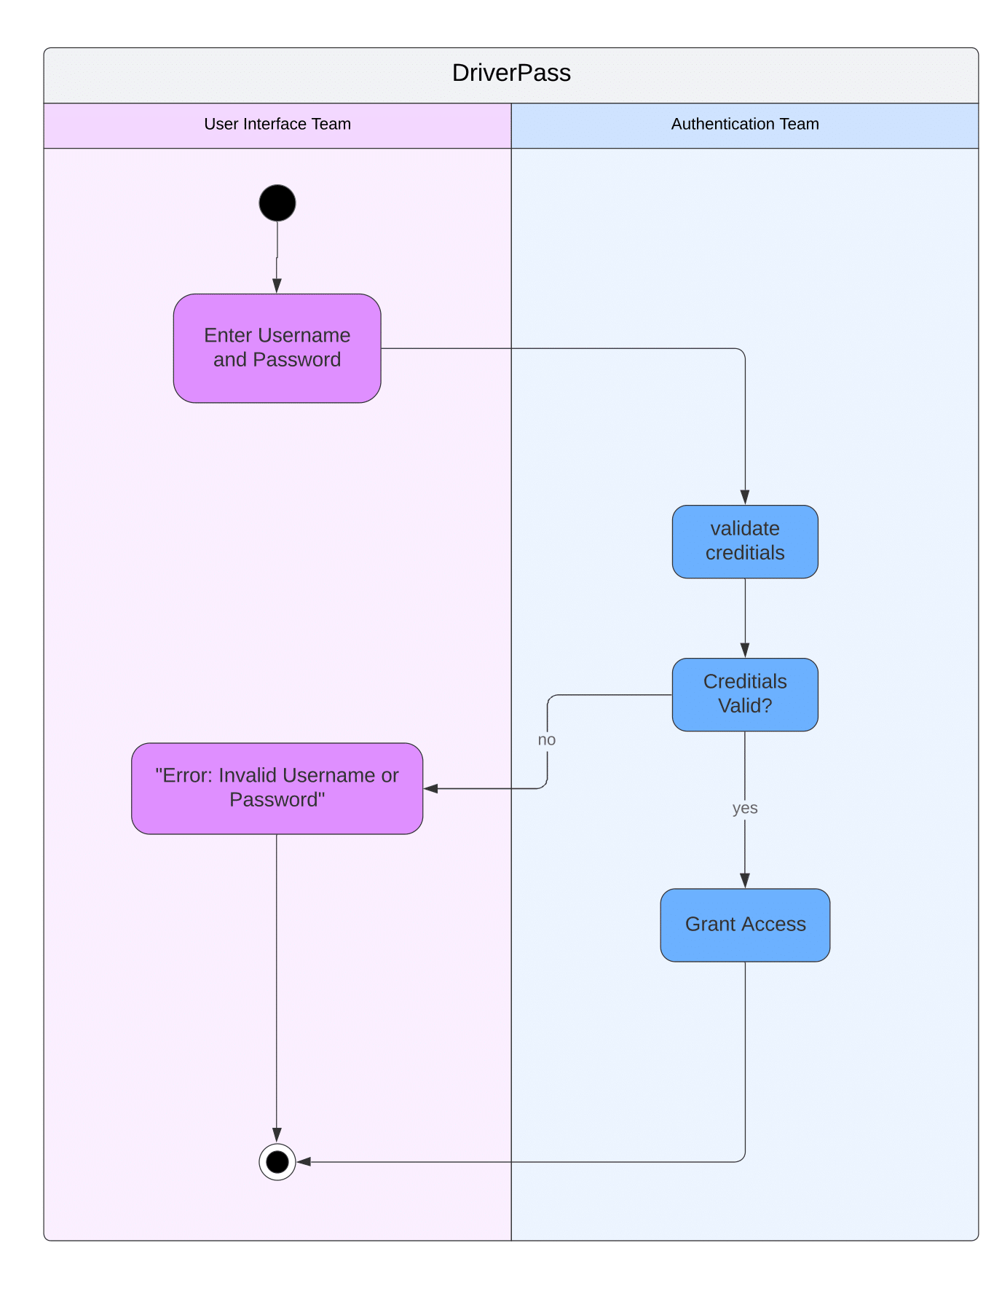

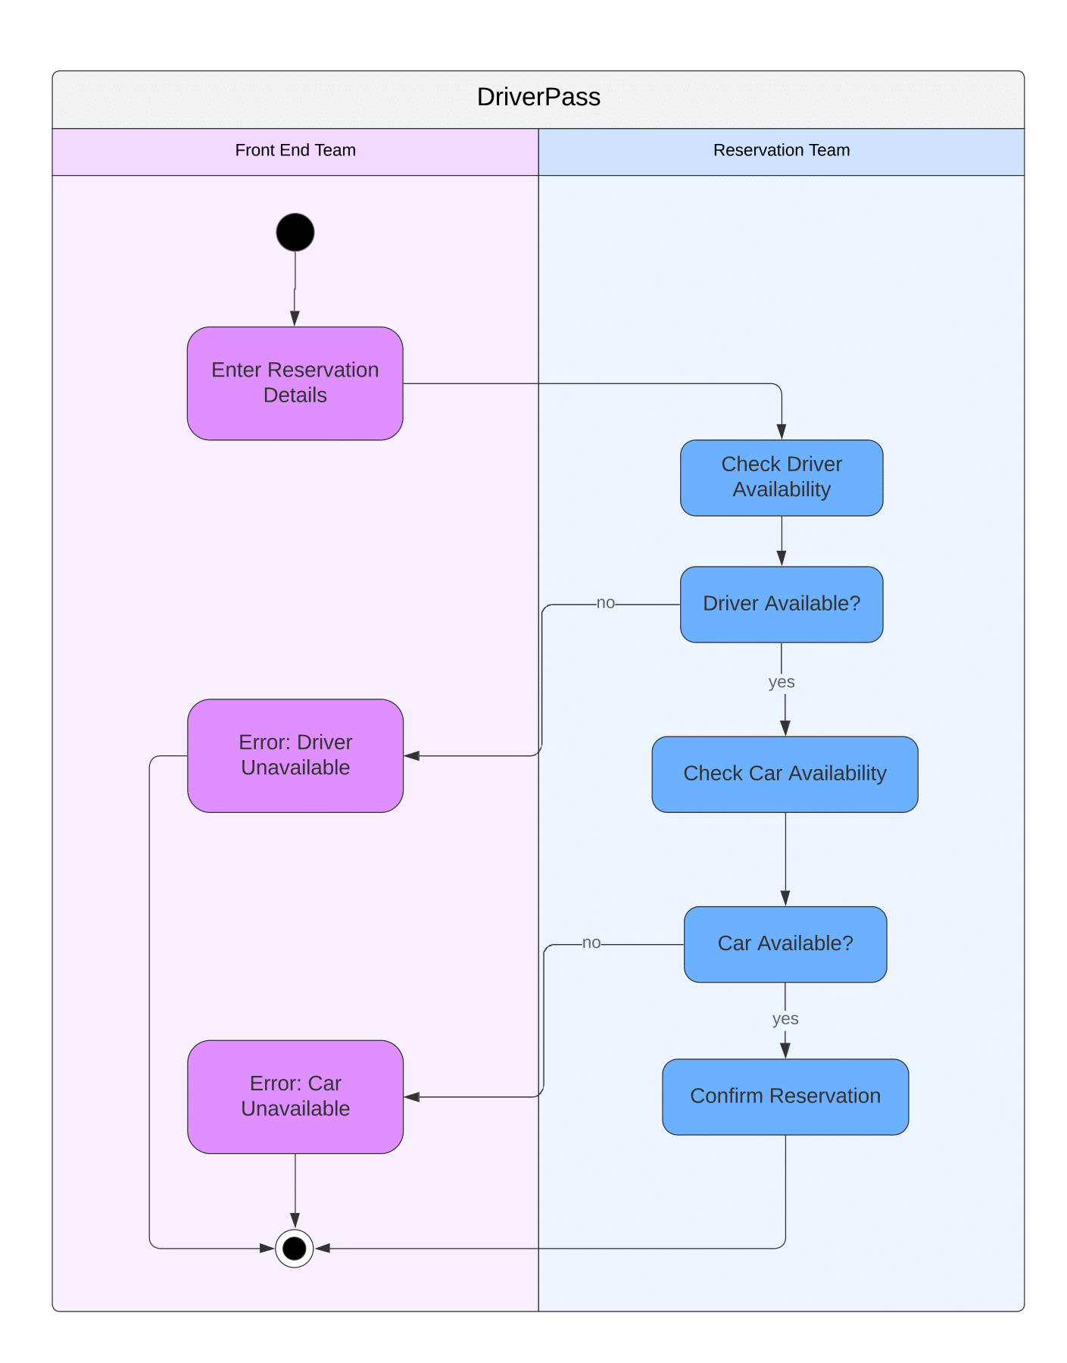

### UML Sequence Diagram

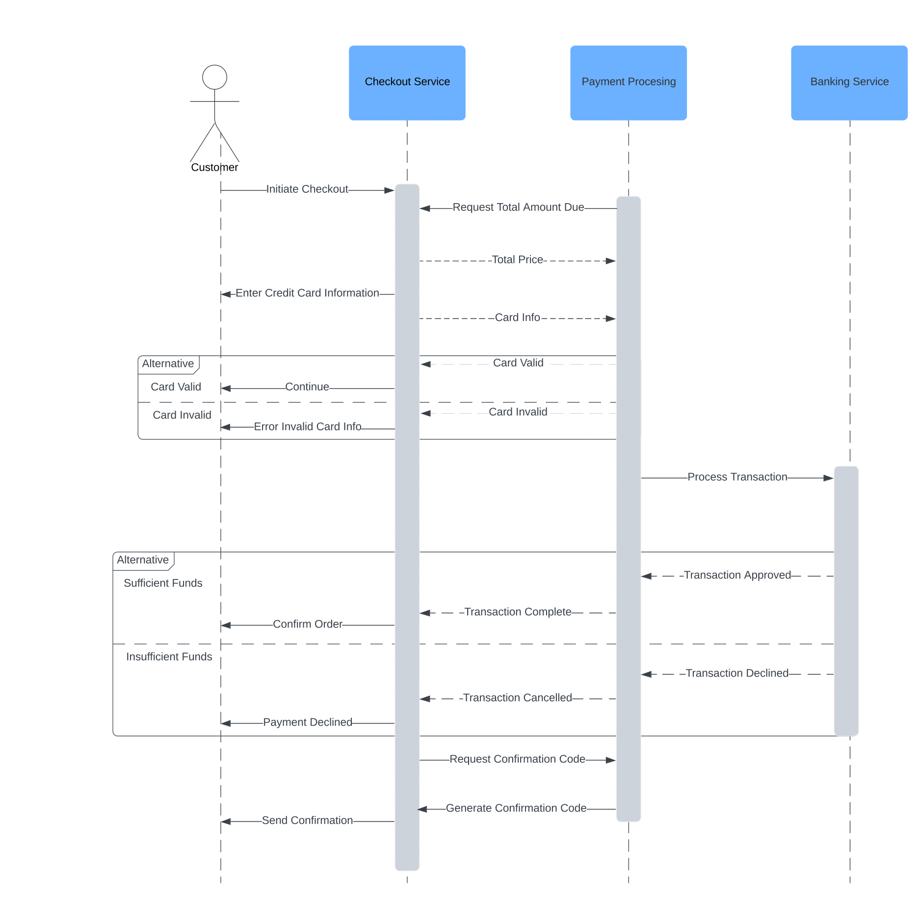

### UML Class Diagram

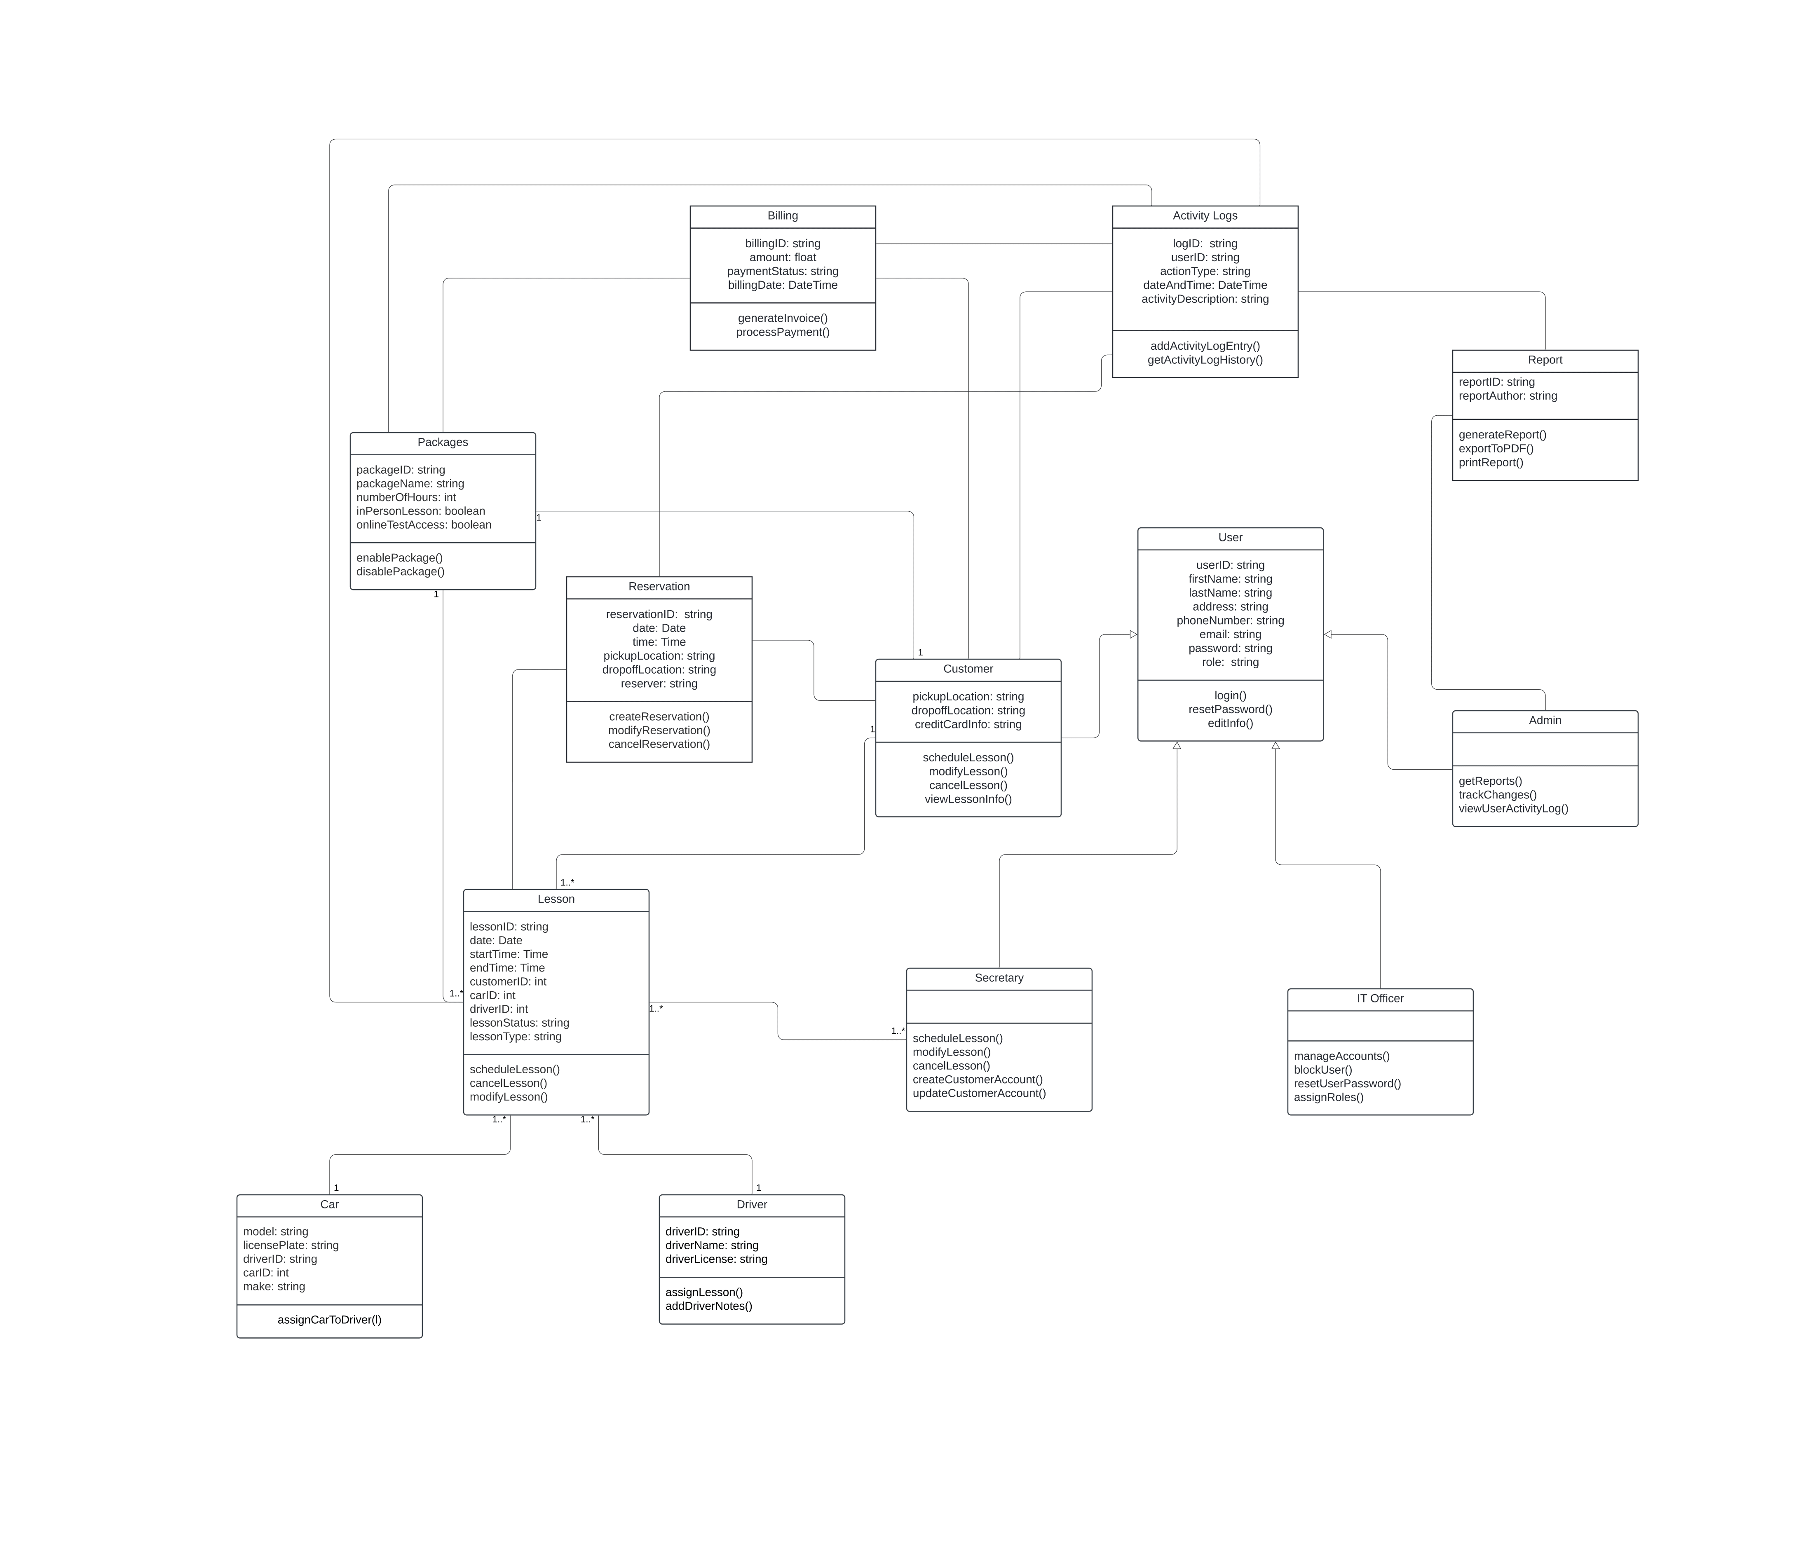

## Technical Requirements

The DriverPass system needs a reliable and secure setup to make sure it runs smoothly and creates good user experience. Instead of using local servers, DriverPass will be hosted on a cloud platform. A cloud setup is powerful and flexible, allowing DriverPass to handle a lot of users at once, while it stores data securely, and backs up everything automatically. Customers, secretaries, drivers, and admins can access the system from their usual devices, like computers, tablets, or smartphones. They don’t need any special equipment, just an internet connection and a modern device.

On the software side, the server will use a stable operating system, like Linux, which is known for being reliable. A web server will handle all incoming requests and send users the pages they need. For storing data like user profiles, reservation details, and activity logs, the system will use a database like SQL. This database will keep all the information organized and easy to retrieve. The actual functions of the system will be powered by a back-end framework. The front end, or what users see and interact with, will be built with a framework to ensure it works well on any device. To protect sensitive data, like customer details and payment info, the system will use encryption both while data is being transferred and when it’s stored.

The overall infrastructure is cloud-based, which means it can grow as DriverPass grows. This cloud setup allows the system to handle more users without slowing down, so the system stays online even if something goes wrong. Security is also a priority, with firewalls, and monitoring in place to prevent unauthorized access. Regular security checks will help ensure that the system stays safe. If there’s ever an issue, backup and recovery solutions will allow the team to quickly restore data, so downtime and data loss are kept to a minimum.